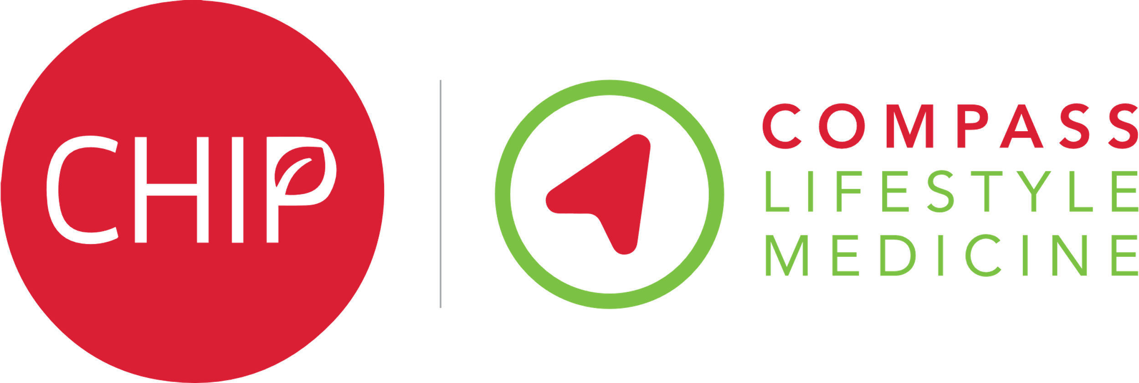
CHIP:
The Complete Health Improvement Programme

What is CHIP?
CHIP stands for the Complete Health Improvement Program. It is an empowering 10-week educational course delivered via weekly online trainings and interactive Q&A sessions by healthcare professionals with expertise in lifestyle medicine. CHIP supports you to make changes to the way you eat, sleep, move and relax.

These changes have been shown to improve your health and, in some cases, put long term conditions such as Type 2 Diabetes into remission. AND until March 2023, and whilst places remain available, it’s completely free of charge for Essex residents! Places are allocated on a first come, first served basis, so if interested, call to sign yourself up asap!

Do I qualify?
The only requirements to join CHIP are that you:
- you are 18 or over
- are currently on medication for Type 2 diabetes
- have access to the internet and an IT device for watching videos completing forms, joining Zoom calls
- are motivated to change your diet and lifestyle to feel healthier and happier!

What participants like most about the CHIP program:
- The camaraderie of all taking part!
- Very knowledgeable, good to be part of the group. Very helpful Facilitators. Learnt so much.
- The encouragement, friendliness and openness of the participants and facilitators.
- It was so informative. It explained how and why things work and that I still have time to make change to my health for the better.
- The weekly video calls were great as you got to discuss things that others were also worrying about. Loved everyone.
- The tutor and doctor as their can-do attitude is infectious. Plus, key information that most do not realise but golden as very helpful.

Testimonials from 2022 participants!
“This has to be the best online course I have done, or any other platform for that matter. I started the course a bit sceptical at first and I planned on quickly moving through the information, but I found it really informative and I was hooked. I appreciate the care and compassion taken during the video calls every Wednesday; Hilda and Miriam (2 of the facilitators) were brilliant and gave us so much information and confidence to move forward. 5 stars from me.”

“The CHIP program works my HbA1C reduced by 5 points. The support from the cohort is a great driver to succeed.”

“As someone who definitely fell into the didn't cook group (I was the queen of ready meals!), I am now cooking my own meals 90% of the time. Without attending this program I'm sure that would not be happening”

“Give your life the kickstart you need, CHIP is the lifestyle change you have been searching for. The program is easy to use and understand. It is very informative, giving you the reasons why you are making the changes and how it works. With all the help and support you need along the way you will make changes for a lifetime and see results immediately.”

“Attendance of the CHIP programme is an eye opener and a valuable resource in enabling a long and healthy life”

Sign me up! How do I join?
If you’ve also decided to empower yourself by joining the CHIP programme, or if you have further questions, all you need to do is call the Essex Wellbeing Service on 0300 303 9988 quoting code: CHIP 2022 so they can go through the 10-minute registration, enrol you onto the programme and help you select which weekly session time you prefer.

Once a weekly session time is full, your CHIP facilitator will contact you for onboarding and next steps, including requesting you arrange blood tests (please keep your blood test results safe so you can log them on the CHIP system to track your success)!

(If you are coming via the eye or podiatry clinic, also please mention this to EWS on booking.)

What can you expect and what do we need from you in exchange for the free programme?
Bring your motivation and an open mind to work through the 10-week programme and apply what you learn.
You’ll need to arrange blood tests via your GP at the start and near the end of the 10 weeks – and also at 6 and 12 months - and please keep your blood work and medical records safe to add them onto the CHIP health forms to track your progress and success! Your facilitator will discuss that with you.
We’ll also ask your feedback at the end of the programme – your experience, results and feedback really matter to us in offering this exciting service to as many people as possible!
In exchange, you can expect to learn loads, experience camaraderie and lots of support from a small and great group of facilitators and fellow participants, and potentially change your life and health for the better!

I’d keen and would like to find out more…
Once enrolled your facilitators will be in contact to tell you all about CHIP and answer any and all your questions.
If you would like to know more before enrolling, you can also go to: www.compasslifestylemedicine.org.uk/chip-in-the-nhs or scan the QR code on the right to watch a video about how the NHS is working with Compass Lifestyle Medicine to support patients in reversing their diseases.
We are excited to invite you on this life-changing journey together!
Just call EWS on 0300 303 9988 quoting code: CHIP 2022 to register!

